# **Project #3**

# **Submitted by: Aman Pandita -** [**panditaa@oregonstate.edu**](mailto:panditaa@oregonstate.edu)

# **Manpreet Kaur -** [**kaurmanp@oregonstate.edu**](mailto:kaurmanp@oregonstate.edu)

**Driving Sustainability:**

**A Geo-Analytical Examination of Tesla's Dominance and EV Adoption in Oregon**

As the climate crisis escalates, the need for sustainable transportation is becoming increasingly evident, leading to the surge of Electric Vehicles (EVs). Our research pivots on the emergence and rapid growth of EVs, focusing primarily on Tesla's rise to prominence and the prevalent adoption trends in Oregon, a state known for its progressive environmental policies. Location information plays a pivotal role in enriching our understanding of this topic, offering insights that encompass both spatial and temporal dimensions.

The geographical locale - Oregon, provides an interesting backdrop for the study, given its eco-conscious reputation and high EV adoption rates. Analysis of location data, such as county-level EV registrations and the spread of charging stations, can offer crucial insights into the diffusion of EVs across the state. Dissecting these location-specific patterns can shed light on the regional disparities in EV adoption and the factors driving these variations - ranging from infrastructural support to economic indicators and policy incentives.

Furthermore, in the landscape of electric vehicles, Tesla's rise has been meteoric, underscoring the significance of location information even further. Tesla's headquarters and major manufacturing facilities, located in California, have had implications for its market dominance in the West Coast, including Oregon. Analyzing Tesla's registration data across Oregon's counties can reveal the influence of these geographical proximity factors on brand adoption.

Notably, understanding the spatial distribution of Tesla's Supercharger network - the company's proprietary charging stations - across Oregon, can illuminate the strategic decisions underpinning Tesla's market expansion. The location of these Superchargers is pivotal in addressing range anxiety, one of the primary hurdles in EV adoption, thus directly influencing Tesla's success in the region.

Location data can also offer temporal insights. By tracking the growth of EV registrations and the evolution of charging infrastructure over time, we can chart the trajectory of EV adoption in Oregon. Trends like the rate of growth in different counties, the increasing density of charging stations, or the shifts in popular EV models can all be mapped year-on-year to visualize the progression of the EV landscape.

In essence, integrating location information into our study offers a multidimensional view of the EV market in Oregon. It allows us to overlay patterns of adoption, infrastructure growth, and brand performance onto the physical map of the state. This geographical lens enhances our ability to understand not only where and how quickly EVs, particularly Tesla vehicles, are being adopted, but also why certain trends are emerging the way they are. Leveraging location data, therefore, enables a comprehensive exploration of the factors driving the EV revolution in Oregon and potentially, insights that can be extrapolated to the broader, global shift towards sustainable transportation.

**Description of the comparison for 3 techniques**

Chloropleth maps, heat maps, and hexagonal binning are all techniques that offer distinctive methods for visualizing geospatial data, each with their unique strengths and challenges.

1. Chloropleth maps are a popular geospatial visualization technique due to their simplicity and intuitive interpretation. They represent data by assigning different colors or shading patterns to geographical regions. Each color or shading pattern corresponds to a particular value or range of values that a variable can take. For instance, one might use a chloropleth map to display population densities across a country, with densely populated areas represented by darker colors and less populated areas by lighter ones. This approach makes chloropleth maps effective for intuitively visualizing geographic clusters or concentrations of data. However, chloropleth maps are not without their limitations. One of the most significant challenges associated with this technique is the potential for visual misrepresentation. The size of a geographical region can affect how the viewer perceives the data. Larger areas naturally draw more attention due to their size, potentially overshadowing smaller regions and skewing the viewer's understanding of the data. This can lead to misinterpretations, especially in scenarios where the variable of interest does not correlate with the size of the regions. Therefore, while chloropleth maps can provide a quick and intuitive understanding of data distribution across geographical regions, they must be used with caution to avoid misleading interpretations​.
2. Heat maps are another valuable tool for visualizing geospatial data. They are particularly useful when dealing with large sets of continuous data. Heat maps use a color spectrum, usually ranging from red to blue or red to green, to represent data. Unlike chloropleth maps, the colors in a heat map do not correspond to geographical boundaries, allowing for a more fluid visualization. This characteristic makes heat maps particularly useful for identifying patterns and "hot spots" or regions of high concentration of the variable. However, heat maps come with their own set of limitations. One of the main challenges associated with heat maps is maintaining data accuracy. Building heat maps often involves using algorithmic extrapolation logic to create a continuous fill of color, especially when dealing with discrete datasets. This process can lead to a situation where the data at any specific point may not be entirely reliable. Furthermore, heat maps can sometimes be difficult to interpret due to the lack of explicit boundaries. Despite these challenges, heat maps remain a powerful tool for visualizing large datasets, especially when the goal is to identify patterns or areas of high data concentration​.
3. Hexagonal binning is a more unique approach to geospatial data visualization. This technique involves creating a grid on the map with regular hexagons, which can then be colored or shaded similarly to a Chloropleth map. Hexagonal binning is particularly beneficial when dealing with a large number of granular data points. Unlike other techniques that may compromise accuracy by using data extrapolation techniques, hexagonal binning allows for a more precise representation of data. Hexagons are chosen because they closely resemble circles, which are ideal for representing data points. Unlike circles, however, hexagons can form continuous grids, providing a more uniform visual representation. Despite these advantages, hexagonal binning comes with its own set of limitations. One of the main challenges with this technique is that it becomes difficult to zoom in or out of the visualization. This can limit the viewer's ability to explore the data in more detail, particularly when dealing with large datasets or complex patterns. Nevertheless, hexagonal binning remains a robust and accurate method for visualizing granular geospatial data, especially when precision is paramount.

In conclusion, Chloropleth maps, heat maps, and hexagonal binning each offer unique approaches to visualizing geospatial data. While all three techniques can provide valuable insights, theyeach come with their own strengths and limitations. Chloropleth maps are useful for their intuitive visualizations and ease of interpretation, but their effectiveness can be compromised by the size of geographical regions and potential for visual misrepresentation. Heat maps excel at representing large datasets and identifying patterns, but they can face challenges with data accuracy and interpretation due to the lack of explicit boundaries. Hexagonal binning offers a solution for handling granular data points without compromising on accuracy, but it may limit the viewer's ability to zoom in or out of the visualization, potentially hindering a more detailed exploration of the data.

Understanding these strengths and limitations is essential when choosing the most appropriate geospatial data visualization technique. The choice between these techniques depends on the nature of the data and the specific goals of the visualization. If the aim is to provide an intuitive understanding of data distribution across geographical regions, a chloropleth map might be the best choice. For identifying patterns or areas of high data concentration in large datasets, a heat map would be more suitable. However, when dealing with granular data and when accuracy cannot be compromised, hexagonal binning provides an effective solution. Therefore, it is critical for data scientists and analysts to understand the specific characteristics and requirements of their data to choose the most appropriate visualization technique. This understanding, coupled with a clear objective for the visualization, can lead to more meaningful and insightful representations of geospatial data.

**Demonstration of newly learned visualization from web search**

**Technology learned:** Power Bi

**Topic:** Analyzing and Visualizing the google play store downloads.

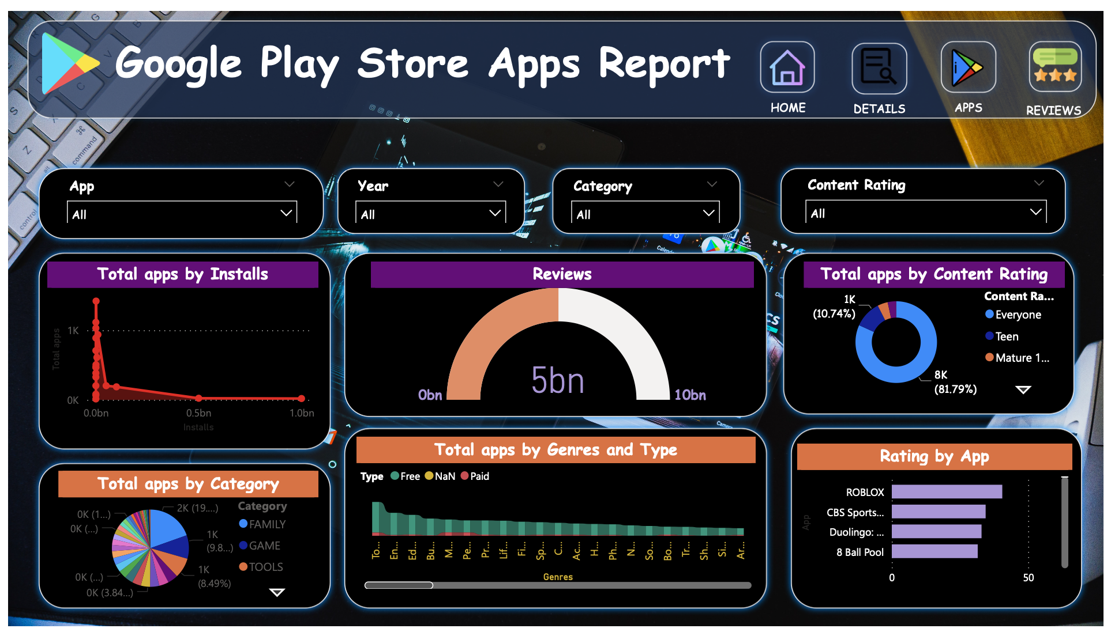

# **Multi-view design**

**Motivation:**

* Sustainable Future: Climate change concerns and the desire for a more sustainable future are propelling the popularity of Electric Vehicles (EVs). By focusing on this topic, our research aims to contribute to the understanding of the pace and patterns of this crucial transition in the automotive industry.
* Market Understanding: The rapid growth of Tesla represents a significant shift in consumer preferences and market dynamics. Detailed analysis of this trend provides valuable insights for various stakeholders, including policymakers, industry players, researchers, and consumers.
* Consumer Behavior: Analyzing new registration data gives us insights into consumer behavior, acceptance levels of EVs, brand preferences, and the potential impact of policy and infrastructure on these decisions. This can help shape strategies for further EV adoption.

**Screen 1: Main Overview Of Data**

**Screen 2: Comparing Sales of Tesla with Other Brands**

**Screen 3: Comparing the Counties and there registrations:  
**

**Screen 4: Comparing Different Charging Infrastructure in Oregon**

**Screen 5: Uncertainty of Prices for EV Charging  
  
**

**Screen 6 (Final): How EV Charging Infrastructure Contributed towards Tesla’s Rise  
  
**

**Steps I used for this project since the beginning.**

1. **Data Collection and Cleaning**
2. **Data Analysis:**   
   Using appropriate statistical techniques, we will identify trends, patterns, and correlations in the data. For example, we'll examine the growth trajectory of different EV brands, especially Tesla, in the Oregon market.
3. **Data Visualization:**   
   Visualizations using tools like Gephi, scatter plots, line graphs, and customized glyphs. These visualizations will present trends over time, compare the performance of various brands, and highlight the specific growth of Tesla.
4. **Interpretation**:   
   Finally, we interpreted the results, drawing conclusions about the state of the EV market in Oregon, the role of different brands, and the particular impact of Tesla. These interpretations will provide valuable insights for stakeholders and contribute to the broader understanding of the transition to sustainable transportation.

In essence, this report aims to dissect the Tesla’s great rise in Oregon vehicle market, with a particular spotlight on Charging Infrastructure role in it. It will offer valuable insights into the factors influencing this change, the current market dynamics, and the trajectory we can anticipate in the years to come.

Note:  
If the Multiview Visualization isn’t clearly visible, I’m providing a link below to my “Figma” drawing.

<https://www.figma.com/proto/oKFNma0rt6syh2FNFwkx8s/Info_Vis?type=design&node-id=1-21675&scaling=scale-down&page-id=0%3A1>

**Design Principles Used:**

1. **Focus on User Understanding**: With a multidimensional data set, it is important that the visualization system aids users in making sense of the information. Simplicity, clarity, and user-centric design should be prioritized. Each screen needs to present the data in an accessible manner, encouraging users to engage and interact with the visuals.
2. **Data Integrity and Accuracy**: It is critical to maintain data integrity throughout all visualizations. This ensures that users draw conclusions based on accurate information. Ensure that the scales, legends, and data mapping are consistent across screens and within each screen.
3. **Cohesive Multi-view Design**: Our system offers multiple views into the data, such as the main overview, sales comparisons, county registrations, and charging infrastructure. To effectively communicate the narrative, ensure that the design and visual language remain consistent across all screens.
4. **Effective Use of Color and Space**: Use color and space efficiently to highlight important data points and trends, avoid clutter, and guide the user's attention. Choose color palettes that offer contrast for emphasis while maintaining harmony across the visuals.
5. **Contextual Information**: To provide depth and understanding, integrate relevant contextual information.
6. **Uncertainty Representation**: As our system covers aspects like the uncertainty of prices for EV charging, it is crucial to represent this uncertainty in a way that is understandable and honest. This involve using techniques like error bars, shaded areas, or other visual cues to indicate the range of uncertainty.
7. **Continuity and Comparison**: Since our project tracks data over time and compares different variables (like Tesla sales versus other brands), ensure that the visualizations enable these comparisons effectively. Using consistent scales and timelines, and employing techniques that visually link different aspects of the data.
8. **Guided Analysis**: While providing room for exploration, also guiding the user through the key insights and findings.